CITY OF YourCommunity
ORDINANCE No. ________
Texas Model OUtdoor Lighting ORDINANCE
AN ORDINANCE amending article xx.x OF YourCommunity CODE OF ORDINANCES; modifying REGULATIONS FOR lighting; PROVIDING FOR THE FOLLOWING: RULES; STANDARDS; PROCEDURES; CRIMINAL PENALTIES including criminal fines not to exceed $ 500.00 per violation and civil fines of up to $500.00 per violation; Repealer; SEVERABILITY; AND, an effective date.
WHEREAS, the City Council of YourCommunity (“City Council”) seeks to provide for the regulation of lighting within the corporate limits of YourCommunity (“City”); and
WHEREAS, the City Council seeks to maintain the value of YourCommuniy’s scenic beauty and charm, which are the keystones of the City's quality of life, through a comprehensive regulatory program that includes restrictions on signs and lighting; and
WHEREAS, the City Council finds that unnecessary and improperly designed light fixtures cause glare, light pollution, light trespass, and wasted resources; and
WHEREAS, glare and light pollution can result in: hazardous circulation conditions for all modes of transportation; reduction in safety; the diminishing ability to view the night sky; and, unattractive townscape; and
WHEREAS, light trespass can eliminate the full use, and enjoyment of property, causing substantial interference; and
WHEREAS, wasted resources can add to any strain that might be placed on the electric grid; and
WHEREAS, the people who live in and near YourCommunity value the natural environment, including the beauty and high quality of the night sky; and
WHEREAS, YourCommunity desires to protect the health, safety and welfare of the general public, and to protect the night sky that adds to the quality of life and economic wellbeing of the City; and
WHEREAS, these lighting regulations will not sacrifice the safety of our citizens or visitors, or the security of property, but instead will result in safer, efficient and more cost-effective lighting; and
WHEREAS, pursuant to Texas Local Government Code Section 51.001, the City has general authority to adopt an ordinance or police regulation that is for the good government, peace or order of the City and is necessary or proper for carrying out a power granted by law to the City; and
WHEREAS, proposed lighting ordinance is designed to benefit residents and businesses in YourCommunity by constituting better nighttime visibility, public safety, energy efficiency, and preservation of the natural night environment to promote tourism; and
WHEREAS, the City Council finds that it is necessary and proper for the good government, peace or order of YourCommunity to adopt an ordinance regulating lighting.
NOW, THEREFORE, BE IT ORDAINED by YourCommunity City Council:
- findings of fact

The foregoing recitals are incorporated into this Ordinance by reference as findings of fact as if expressly set forth herein.
- ENACTMENT

Chapter XX, Article XX.XX of YourCommunity Code of Ordinances is hereby established and incorporated into this Ordinance for all intents and purposes.
- repealer

To the extent reasonably possible, ordinances are to be read together in harmony. However, all ordinances, or parts thereof, that are in conflict or inconsistent with any provision of this Ordinance are hereby repealed to the extent of such conflict, and the provisions of this Ordinance shall be and remain controlling as to the matters regulated, herein.
- severability

Should any of the clauses, sentences, paragraphs, sections or parts of this Ordinance be deemed invalid, unconstitutional, or unenforceable by a court of law or administrative agency with jurisdiction over the matter, such action shall not be construed to affect any other valid portion of this Ordinance.
- codification

The City Secretary is hereby directed to record and publish the attached rules, regulations and policies in the City’s Code of Ordinances as authorized by Section 52.001 of the Texas Local Government Code.

- effective date

This Ordinance shall be effective immediately upon passage and publication of caption.
- proper notice & meeting

It is hereby officially found and determined that the meeting at which this Ordinance was passed was open to the public, and that public notice of the time, place and purpose of said meeting was given as required by the Open Meetings Act, Texas Government Code, Chapter 551. Notice was also provided as required by Chapter 52 of the Texas Local Government Code.

PASSED & APPROVED this, the ___ day of ___________ 20xx, by a vote of ___ (ayes) to ___ (nays) to ___ (abstentions) of the City Council of YourCommunity, Texas.

CITY OF YourCommunity:

by: _____________________________
Mayor _______________

ATTEST:

_____________________________
_______________-, City Secretary

APPROVED AS TO FORM:
__________________, City Attorney

ARTICLE XX.XX OUTDOOR LIGHTING

Sec. XX.XX.001 - Title, purpose and scope.

(a) This article shall be known and cited as the "Outdoor Lighting Ordinance."

(b) The purpose of this article is:

(1) To reduce glare and improve nighttime visibility which contributes to safer, more secure, and attractive outdoor living spaces;

(2) To encourage efficient, controlled lighting that conserves energy;

(3) To make our community a better place to live and work and a more inviting place for tourist to visit;

(4) To protect properties from light trespass;

(5) To restore and preserve our heritage of a clear, dark night sky; and

(6) To position the City to apply for the designation of International Dark Sky Community.

(7) To have lights at night that are directed where light is wanted, are a warm color, and the appropriate amount of light.
(8) To prevent light at night from being wasted offsite, off property, or into the night sky.

(c) Scope

(1) This article shall apply within the City limits, hereinafter referred to as “City”.

(2) Nothing herein shall be construed as preventing or limiting the City from applying this article within the surrounding areas where the City asserts powers of extraterritorial jurisdiction through agreements with property owners, or as a term affixed to a conditional approval (such as a variance) or if authorized by the State of Texas.

Sec. XX.XX.002. - Definitions.

(a) The following definitions are hereby adopted for the purposes of this article:

Adaptive controls mean mechanical or electronic devices, when used in the context of outdoor lighting systems, intended to actively regulate the switching, duration, and/or intensity of light emitted by the outdoor lighting system. Examples of adaptive controls include timers, dimmers and motion-sensing switches.

Beam of a light fixture means the spatial distribution of the emitted light.

Correlated Color Temperature (CCT) means a measure of the color properties of light emitted by lamps, being equal to the temperature, expressed in Kelvins (K). CCT values are typically provided on lighting manufacturer packaging or data sheets.

Decorative holiday lighting means low-intensity string lights, whose luminous output does not exceed fifty (50) lumens per linear foot, and fully-shielded floodlights, whose luminous output does not exceed one thousand (1,000) lumens and which are aimed and oriented in such a way as to not create light trespass onto another property nor into the night sky, operated for a limited number of days per calendar year.

Electronic Message Display means any illuminated sign of an informative or advertising nature, whether on-or off-premise, and operable at night, whose content is made visible to the viewer by means of luminous elements under active electronic control and therefore subject to alteration in order to vary the content of the message. Electronic displays may be either static or dynamic in terms of light color and intensity.

Existing light fixtures means those outdoor light fixtures already installed at the time this article is adopted.

Floodlight means a light fixture having a wide beam.

Fully Shielded means an outdoor luminaire constructed so that in its installed position, all of the light emitted from the light fixture is projected below the horizontal plane passing through the lowest light-emitting part of the fixture.

Glare means visual discomfort or impairment caused by a bright source of light in a direction near one's line of sight.

Greenhouse means any building that is constructed of glass, plastic, or other transparent material in which plants are grown under climate-controlled conditions and includes hoop houses and other similar structures.

Illuminance means the intensity of light in a specified direction measured at a specific point.

Light source means a light emitting portion of the luminaire and any diffusing elements and surfaces intended to reflect or refract light emitted from the lamp individually or collectively, for example, a lamp, bulb, lens, highly reflective surface, or frosted glass.

Light pollution means the unintended, adverse and /or obtrusive effect of the use of outdoor light at night.

Light trespass means light emitted from fixtures designed or installed in a manner that unreasonably causes light to fall on a property other than the one where the light is installed, in a motor vehicle drivers’ eyes, or upwards toward the sky. If the light appears star-like from another property or the public roadway, the light is creating light trespass. It is expected that the illumination produced by a light source may be viewed from other properties but the light source itself should not be visible from other properties. Exhibit 3 of Section XX.XX.020 is a sample educational illustration about light trespass.

Lumen means the unit of measurement used to quantify the amount of light produced by a bulb or emitted from a light source. Lumen values are typically provided on lighting manufacturer packaging or data sheets. For the purposes of this article, unless otherwise stated, the lumen output values shall be the initial lumen output ratings as defined by the manufacturer, multiplied by the lamp efficiency. Lamp efficiency of 95% shall be used for all solid-state lamps and 80% for all other lamps, unless an alternate efficiency rating is supplied by the manufacturer.

Lumens per Net Acre means the total outdoor light output, as defined in this article, divided by the number of acres, or part of an acre with outdoor illumination. Undeveloped, non-illuminated portions of the property may not be included in the net acreage calculation.

Luminaire means a complete lighting assembly or lighting fixture, consisting of a lamp, housing, optic(s), and other structural elements, but not including any mounting pole or surface.

Luminance is a measure of light emitted by or from a surface.

Nit is the standard unit of measure of luminance used for internally illuminated signs, digital signs, or electronic message displays.

Outdoor Lighting means temporary or permanent lighting that is installed, located, or used in such a manner to cause light rays to shine outdoors. Nonresidential fixtures that are installed indoors that cause light rays to shine outside are considered outdoor lighting for the intent of this article. See Exhibit 1 of Section XX.XX.020 for an illustration of this type of situation. Residential fixtures installed indoors generating more than 3,800 lumens (approximately equal to a 300-watt incandescent bulb) that cause light to shine outside are also considered outdoor lighting for the intent of this article. All of the lighting that illuminates the translucent portion of a greenhouse or solarium, including roofing material, is considered outdoor lighting for the intent of this article.

Pedestrian Activity Levels means the classification of pedestrian usage of an area based on specific criteria.
- High pedestrian activity areas: More than 100 pedestrians during the highest nightly average one-hour volume period. For example, this would include downtown areas with dense urban development (typically over 3,000 pedestrians per square kilometer), areas around major arenas.
- Medium pedestrian activity areas: Between 11 and 99 pedestrians during the highest nightly average one-hour volume period.
- Low pedestrian activity areas: 10 or fewer pedestrians during the highest nightly average one-hour volume period.
Private lighting means outdoor light fixtures that are owned or leased or operated or maintained or controlled by individual persons, including but not limited to families, partnerships, corporations, and other entities engaged in the conduct of business or other non-governmental activities.

Public lighting means outdoor light fixtures that are owned or leased or operated or maintained or controlled by the City or other governmental entity or entities completely or partly funded by grants obtained by the City or its agents from federal, state or private sources. The light fixtures are normally located on, but are not limited to, streets, highways, alleys, easements, parking lots, parks, playing fields, schools, institutions of higher learning, and meeting places.

Road Classifications means the type of street or roadway based on usage and the traffic it serves.
- Major (arterial) street: That part of the roadway system that serves as the principal network for through traffic flow. These routes connect areas of principal traffic generation and important roadways entering and leaving the city. They are sometimes subdivided into primary and secondary classifications; however, such distinctions are not necessary for the purpose of street lighting. These routes primarily serve through-traffic and secondarily provide access to abutting property.
- Collector street: A road servicing traffic between major and local streets. These are streets used mainly for traffic movements within residential, commercial, and industrial areas. Collector streets may be used for truck or bus movements and give direct service to abutting properties.
- Local street: Local streets are used primarily for direct access to residential, commercial, industrial, or other abutting property. They make up a large percentage of the total street system but carry a small proportion of vehicular traffic.
Sag-lens or drop-lens fixture means a fixture, typically seen on older streetlights or parking lot lights, where the lens extends below the lowest opaque part of the fixture such that light is scattered above the horizontal plane.

Searchlight means a light fixture having a narrow beam intended to be seen in the sky.

Spotlight means a light fixture having a narrow beam.

Temporary lighting means non-permanent lighting installations installed and operated for a duration not to exceed thirty (30) days.

Total outdoor light output means the total amount of light, measured in lumens, from all outdoor light fixtures within the illuminated area of a property. The lumen value to be used in the calculation is the lumen value as defined in this article. To compute the total, add the lumen outputs attributed to each light fixture together.

Sec. XX.XX.003. – Nonconforming existing outdoor light fixtures.

(a) All existing outdoor lighting that was legally installed before the enactment of this article, that does not conform with the standards specified by this article shall be considered nonconforming. Nonconforming outdoor lighting is allowed to remain until required to be replaced pursuant to the terms of this article.

(b) If more than fifty percent (50%) of the total appraised value of a structure (as determined from the records of the county’s appraisal district), has been destroyed, the nonconforming status expires and the structure’s previously nonconforming outdoor lighting must be removed and may only be replaced in conformity with the standards of this article.

(c) Nonconforming outdoor lighting shall be brought into conformance with this article as follows:

(1) Nonresidential Application. All existing outdoor lighting located on a subject property that is part of an application for a rezoning application, conditional use permit, subdivision approval, or a building permit for a major addition is required to be brought into conformance with this article before final inspection, issuance of a certificate of occupancy, or final plat recordation, when applicable. For the following permits issued by the City, the applicant shall have a maximum of 90 days from date of permit issuance to bring the lighting into conformance: site development permit, sign permit for an externally or internally illuminated outdoor sign, initial alcoholic beverage permit, initial food establishment permit, and on-site sewage facility permit.

(2) Residential addition or remodel. Nothing herein shall be construed to terminate a residential property’s nonconforming status as a result of an addition or remodel. However, all outdoor residential lighting that is affixed to a construction project requiring a building permit is required to conform the standards established by this ordinance.

(3) Abandonment of nonconforming. A nonconforming structure shall be deemed abandoned if the structure remains vacant for a continuous period of six (6) months. In that instance, the nonconforming status expires and the structure’s previously nonconforming outdoor lighting must be removed and may only be replaced in conformity with the standards of this article.

(d) It is unlawful to expand, repair or replace outdoor lighting that was previously nonconforming, but for which the prior nonconforming status has expired, been forfeited, or otherwise abandoned.

(e) Outdoor lighting on any property that is not in conformance with this article shall be brought into conformance with this article within five (5) years from the date of adoption of this article. All new construction and/or new luminaires installed (including replacements for existing fixtures) shall comply after the adoption of this article.

(f) Amortization Extension. Residential property owners may request from the City an amortization extension of up to a maximum of ten (10) years from the date a nonconforming fixture was installed provided that the fixture was compliant with existing City ordinances at the time is was installed, and that date of installation can be substantiated via documents, date stamped photographs, etc. or, at the prerogative of the City Administrator, corroborative written statements.

(1) Amortization extensions to the date at which outdoor lighting shall conform with this article shall be on a per fixture basis with the following requirements:

(i) The light fixture must be documented to cost at least $100 when originally purchased;

(ii) The fixture cannot be brought into compliance by changing the bulb or lighting element or installing shielding;

(iii) If the bulbs or other lighting elements of the fixture require replacement during the amortization period, the replacement bulbs or lighting elements shall not be rated in excess of 2700 Kelvin.

Sec. XX.XX.004. - General Provisions

(a) Shielding and Light Output.

(1) Unless exempted elsewhere in this article, all outdoor lighting shall be fully shielded so that the light source shall not be visible from any other property.

(2) Luminaire mounting height or topography or proximity to other properties may cause public or private outdoor light fixtures to require three hundred sixty degree shielding to hide the source of the light to prevent glare, light trespass, or an unsafe condition on properties other than the one on which it is installed.

(3) Public or private outdoor street or area lights shall utilize a minimum output consistent with the safety of vehicular traffic and/or pedestrians by following the lighting level recommendations of the Illuminating Engineering Society. Communities without access to the IES documents may choose to use the following code instead:
Public or private outdoor street or area lights shall utilize a minimum output consistent with the safety of vehicular traffic and/or pedestrians as defined by the Illuminating Engineering Society by following the pavement illuminance criteria below for roadways and intersections of major, collector or local roads:
(i) For roadways with a cement or a light-colored surface, maximum average illuminance is limited to 0.6 footcandles (fc) with a uniformity ratio of 3.0 on major roads, 0.4 fc with a uniformity ratio of 4.0 on collector roads, and 0.3 fc with a uniformity ratio of 6.0 on local roads.
(ii) For roadways with an asphalt or dark colored surface, maximum average illuminance is limited to 0.8 fc with a uniformity ratio of 3.0 on major roads, 0.6 fc with a uniformity ratio of 4.0 on collector roads, and 0.4 fc with a uniformity ratio of 6.0 on local roads.
(iii) For intersections of major, collector or local roads, the maximum average illuminance is set by a combination of the types of roads that intersect and the pedestrian activity at that intersection as reflected in Exhibit 6.

(4) All of the lighting that illuminates the translucent portion of a greenhouse or solarium must be shielded so that no direct light shines outside of the structure and no more than 4% of the reflected or refracted illumination is allowed to escape outside the structure.

(5) Outdoor light fixtures with a maximum output of 200 lumens per fixture, regardless of the number of bulbs, may be left unshielded provided the fixture conforms to all other stipulations of this article. The output from these fixtures shall not exceed 10% of the lumens per net acre allowed by this article. (Your community may choose to increase the 200 lumen per fixture limit to as much as 1000 lumens which would be an appropriate level for the downtown business area of a large city.)

(b) Light Trespass.

(1) Light trespass is prohibited. No luminaire installed within the City limits, except streetlights that are governmental owned or governmental approved to be installed in the right-of-way, shall create conditions of light trespass. Governmental owned or approved streetlights may only create light trespass up to ten (10) feet beyond the roadway.

(c) Outdoor Sports Facilities.

(1) Lighting at public and private outdoor sports facilities, including but not limited to playing fields, arenas, tracks, and swimming pools, will be shielded to the greatest practical extent to reduce glare, safety hazards, light trespass, and light pollution;

(2) Will provide levels of illuminance that are adjustable according to task, allowing for illuminating levels not to exceed nationally recognized Illuminating Engineering Society of North America (IESNA) standards according to the appropriate class of play, as well as for lower output during other times, such as when field maintenance is being actively performed; and

(3) Shall be provided exclusively for illumination of the surface of play and adjacent viewing stands, and not for any other application, such as lighting a parking lot; and

(4) Must be extinguished by 11:00 p.m. or within one (1) hour of the end of active play. The outdoor sports facility lighting shall be fitted with mechanical or electronic timers to prevent lights from being left on accidentally overnight.

(5) Outdoor sports facility lighting will be exempted from the other regulations of this article if its design and installation, as certified by a professional engineer (PE) licensed in the state of Texas, adheres to the version of the International Dark-Sky Association’s Criteria for Community-Friendly Outdoor Sports Lighting operative at the time when the construction permit is submitted to the City for review.

(d) Towers. No lighting of towers and associated facilities is allowed, except by permit, and except as required by the Federal Aviation Administration or other federal or state agency. In coordination with the applicable federal or state agency, the applicant shall determine the maximum height of the tower that would not require lighting. If a proposed tower would require lighting, the applicant shall demonstrate that a tower height that requires lighting is necessary. Such justification shall include documentation showing:

(1) Coverage limitations;

(2) Type of system (e.g. cellular, radio, television);

(3) Technical and engineering details of the lighting to be installed; and

(4) Requirements of federal, state, and local agencies.

If a tower height that requires lighting is justified, slowly blinking red lights must be used at night. White strobe lights at night are prohibited.

(e) Color Temperature.

- The correlated color temperature (CCT) of street and/or area lights may not exceed 2700 Kelvins.
- The correlated color temperature (CCT) of all other outdoor luminaries shall not exceed 3000 Kelvins except that luminaries directed down onto a fuel pump or luminaries approved through the International Dark-Sky Association’s Community-Friendly Outdoor Sports Lighting program may be rated up to 4000 Kelvin.

(2) Luminaries rated below 2500 Kelvin are encouraged for better nighttime visibility.

(f) Service Station Canopies and other building overhangs. All luminaires mounted on or recessed into the lower surface of service station canopies or other overhangs shall be fully shielded and utilize only flat lenses or windows. Shielding must be provided by the luminaire itself, and not by surrounding structures such as canopy edges. Light directed on service station pumps may be angled to illuminate the pump to the level of federal standards and to shield the light from normal view.

(g) General curfew.

(1) In all nonresidential zones,

(i) All privately owned exterior lighting not adaptively controlled shall be extinguished by 11:00 p.m. or within one (1) hour of the end of normal business hours, whichever occurs later.

(ii) Exterior lighting with adaptive controls shall reduce lighting to 25% or less of the total outdoor light output allowed by 11:00 p.m. or within one (1) hour of the end of normal business hours, whichever occurs later. Adaptive controls may be used to activate lights and resume normal light output when motion is detected and be reduced back to 25% or less of total outdoor light output allowed within 5 minutes after activation has ceased, and the light shall not be triggered by activity off property.

(iii) Businesses whose normal operating hours are (24) twenty-four hours per day are exempt from this provision.

(2) All publicly owned lighting not adaptively controlled must be fully extinguished by 11:00 p.m., or within one (1) hour of the end of occupancy of the structure or area to be lit, whichever is later.

(3) All outdoor lighting is encouraged to be turned off when no one is present to use the light.

(h) Lumen Caps. The lumen per net acre values are an upper limit and not a design goal; design goals should be the lowest levels that meet the requirement of the task. Lumen per net acre values exclude governmental owned street lights used for illumination of public rights-of-way and outdoor recreation facilities.

(1) Nonresidential Property. Total outdoor light output installed on any nonresidential property shall not exceed 100,000 lumens per net acre in any contiguous illuminated area;

(2) Residential Property. Total outdoor light output installed on any residential property shall not exceed 25,000 lumens per net acre in any contiguous illuminated area.

(3) The lumen output of a fixture directed onto a highly reflective surface such as water, polished metal, or any surface with a high gloss finish is encouraged to be the lowest level of light required to accommodate the purpose. The lumen output attributed to a fixture so directed onto a highly reflective surface shall be double the amount defined in this article for the purpose of calculating the lumens per net acre.

(i) Adaptive Controls. All new publicly owned lights, including streetlights, will incorporate adaptive controls (e.g., timers, motion-sensors, and light-sensitive switches) to actively regulate the emission of light from light fixtures such that the lighting of areas is restricted to times, places and amounts required for safe occupancy.

(j) Flagpoles. Property owners are encouraged to not illuminate flagpoles at night, but rather to hoist flags after dawn and lower flags before sunset. If flags are illuminated at night, lighting of up to a total of two (2) flags per property is permitted with the following conditions:

(1) Flagpoles with a height greater than 20 feet above ground level shall be illuminated only from above. This may be achieved by utilizing a luminaire attached to the top of the flagpole or a luminaire mounted above the top of the flagpole on a structure within fifteen (15) feet of the flagpole and must comply with all sections of this article. The total light output from any luminaire mounted on top of or above a flagpole shall not exceed 800 lumens.

(2) Flagpoles with a height equal to or less than twenty (20) feet above ground level may be illuminated from below. If ground-level illumination is used, flagpoles may be illuminated with up to two (2) spotlight type luminaires, utilizing shields or diffusers to reduce glare, whose maximum combined lumen output is 75 lumens per linear foot of pole height, measured from the level of the luminaire above grade to the top of the flagpole. Luminaires are to be mounted so that their lenses are perpendicular to the flagpole and the light output points directly toward the flag(s).

(k) Prohibitions. The use of the follow types of outdoor lighting are prohibited, except as specifically exempted here or elsewhere in this article.

(1) Sag-lens or drop lens fixtures.

(2) Any luminaire that uses mercury vapor lamps.

(3) Searchlights, skybeams, and similar lighting, except as required by response
personnel during emergency conditions.

(4) Any light that dynamically varies its output by intermittently fading, flashing, blinking, or rotating. This type of lighting includes strobe lighting.

(l) Warranting. New installations of outdoor lighting will only be installed on public properties and right-of-way upon determination by the City Administrator that a public safety hazard exists in the area to be lit, and that the hazard can only be effectively mitigated through the use of outdoor lighting and not through some other passive means, such as reflectorized roadway paint or markers.

Sec. XX.XX.005. - Sign illumination.

(a) All permanent signs may be non-illuminated, illuminated by internal, internal indirect (halo), or lit by external indirect illumination, unless otherwise specified. All illuminated signs shall be extinguished at 11:00 p.m. or within one (1) hour of the end of normal business hours, whichever occurs later. All sign illumination must comply with the correlated color temperature (CCT) requirements of this article.

(b) Top-down lighting. Externally illuminated signs shall be lit only from the top of the sign, with fully shielded luminaires designed and installed to prevent light from spilling beyond the physical edges of the sign.

(c) Outdoor internally illuminated signs (whether free standing or building mounted) shall be subject to all the following requirements:

(1) The sign must be constructed with an opaque background and translucent letters and symbols or with a dark colored background and lighter letters and symbols. (See Exhibit 5 of Section XX.XX.020 for examples).

(2) The internally illuminated portion of the sign cannot be white, cream, off-white, light tan, yellow or any light color unless it is part of a registered logo that does not have an alternate version with dark tones. Light tone colors such as white, cream, off-white, light tan, yellow or any light color are permitted in the logo only, provided that such colors in the logo shall represent not more than 33% of the total sign area permitted.

(3) The internal illumination, between sunset and sunrise, is to be the lowest intensity needed to allow the sign to be visible for up to 1/2 mile from its installation and shall not exceed 100 nits.

(4) Size limit. The luminous surface area of an individual sign shall not exceed 200 square feet.

(5) Permitted location. Off-premise signs shall not be placed within one thousand (1,000) feet of another off-premise sign on the same side of an arterial street or highway, regardless of face orientation, or within one thousand (1,000) feet of a residential area.

(d) Electronic Message Displays.
- Electronic Message Center displays are prohibited within or adjacent to sensitive areas. These may include, but are not limited to: natural areas, beaches, wetlands, state and national parks, wildlife refuges, residential areas, observatories, and military training grounds. (Setbacks in excess of 1 mile (1600 meters) from sensitive areas may be warranted. Distance setbacks shall be assessed on a case-by-case basis, considering the cumulative effect of multiple EMCs. City staff should document setback requirements for each sensitive area within the jurisdiction and include reference to those setbacks in the ordinance.)
- The total number of EMCs on any given mile of roadway is limited to two and the total square footage within any given mile is limited to 800 square feet.

- Messages appearing on electronic message center displays shall not be displayed for less than (30) seconds and shall require no longer than 0.25 seconds to transition from one message to another. Moving and/or flashing text or images are prohibited.

- Electronic message displays are to be gradually dimmed between day and night mode from sunset to one hour after sunset to provide the proper contrast ratio with the ambient illumination level, and similarly before sunrise. Within one hour after sunset luminance levels shall not exceed the following:
  - In areas with low ambient lighting where lighting might adversely affect flora and fauna or disturb the character of the area, such as rural and low density residential areas, the nighttime maximum luminance is not to exceed 20 candelas per square meter of signage.
  - In areas with moderate ambient lighting where the vision of human residents and users is adapted to moderate light levels such as light commercial business areas and high-density or mixed-use residential areas, the nighttime maximum luminance is not to exceed 40 candelas per square meter of signage.
  - In areas with moderately high ambient lighting where the vision of human residents and users is adapted to moderately high light levels, the nighttime maximum luminance is not to exceed 80 candelas per square meter of signage.
- On-premises electronic message displays are to be switched off completely after 2300 hours or 30 minutes after the close of business, whichever is later, and remain off until one hour before sunrise.

- Electronic Message Centers intended for traffic and safety information may operate without curfew but must follow all other requirements.

Sec. XX.XX.006. - Plan Submission and Compliance Review.

(a) Any individual applying for a compliance review or building permit under this article intending to install new outdoor lighting or update existing outdoor lighting shall file a lighting plan with the City. A lighting plan shall be filed at the same time as any other plans required by the City. The individual may obtain from City staff a document that lists all of the items that comprise a proper and complete outdoor lighting submittal. The submittal shall contain, but shall not necessarily be limited to the following:

(1) Plans indicating the number and location on the premises of proposed and existing light fixtures, the type of light fixture (the manufacturer’s order number), the lamp type, Kelvin rating, initial lumens produced, the mounting height for each fixture, adaptive controls, building elevations for any structure whose interior lighting is defined as outdoor lighting per this article and the manufacturer’s specification sheet for each light fixture.

(2) The number of acres or part of an acre that is to be illuminated contiguously, the square footage of the footprint for each structure within the area to be illuminated; and

(3) Any other evidence that the proposed installation will comply with this ordinance.

(b) The lighting plan shall be reviewed by the City building official to determine compliance with this article, taking into account all factors, including but not limited to, levels of illuminance, luminance, glare, safety hazards, light trespass, and light pollution. The building official may seek input from community members knowledgeable about outdoor lighting during the review process. The building official shall approve or reject the plan within 30 days of submission, returning it to the applicant with an explanation. The applicant shall not move forward with the outdoor lighting project until the lighting plan is approved. After the lighting plan is approved, no substitutions may be made for approved light fixtures without re-submitting the plan for review with the substitutions.

Sec. XX.XX.007. - Exemptions, temporary permitting, amendments, enforcement, civil remedies and public nuisance.

(a) This article shall not apply to the following:

(1) Decorative holiday lighting energized for no more than 60 days per calendar year, with illumination only during the hours of 6:00 a.m. to 11:00 p.m. each day, and with the provision that flashing holiday lights are prohibited on nonresidential properties;

(2) String, festoon, bistro, and similar lighting, provided that the emission of no individual lamp exceeds fifty (50) lumens, and no installation of such lighting exceeds, in the aggregate, six thousand (6,000) lumens on any one property, and the lights must be rated at or below 2700 Kelvin;

(3) Underwater lighting of swimming pools and similar water features;

(4) Lighting required by law to be installed on surface vehicles and aircraft;

(5) Airport lighting required by law;

(6) Lighting required by federal or state laws or regulations;

(7) Temporary emergency lighting needed by law enforcement, fire and other emergency services as well as temporary building egress lighting whose electric power is provided by either battery or generator;

(8) Lighting employed during emergency repairs of roads and utilities provided such lighting is deployed, positioned and aimed such that the resulting glare is not directed toward any roadway or highway or residence;

(9) Temporary lighting at construction projects provided such lighting is deployed, positioned and aimed such that the resulting glare is not directed toward any roadway or highway or residence;

(10) Temporary lighting, permitted in this article, for theatrical, television, performance areas, or events provided the lights are positioned safely and do not create issues of light trespass.

(b) Temporary Permitting

(1) Lighting such as that needed for theatrical, television, performance areas, or events may be allowed by temporary exemption. Temporary lighting that does not conform to the provisions of this article may be approved at the discretion City Council or the City Administrator subject to submission of an acceptable Temporary Outdoor Lighting Permit.

(2) Permit term and renewal. Permits issued shall be valid for no more than seven (7) calendar days and subject to no more than one renewal, at the discretion of City Council or the City Administrator, for an additional seven (7) calendar days.

(3) Conversion to a permanent status. Any lighting allowed by Temporary Outdoor Lighting Permit that remains installed after fourteen (14) calendar days from the issue date of the permit is declared permanent and is immediately subject to all of the provisions of this article.

(4) Permit contents. A request for a Temporary Outdoor Lighting Permit for a temporary exemption to any provision of this article must list the specific exemption requested and the start and end date of the exemption. Search lights, skybeams and similar lighting will not be allowed. The City may ask for any additional information which would enable a reasonable evaluation of the request for temporary exemption.

(c) Amendment. This article may be amended from time to time as local conditions change, and as changes occur in the recommendations of nationally recognized organizations such as the Illuminating Engineering Society of North America and the International Dark-Sky Association, if the council wishes to do so.

(d) Enforcement.

(1) It will be the responsibility of the City to publish this article in the newspaper of record and to disseminate the ordinance by other appropriate means; to publish information about the ordinance on the City website; and, as time permits, to inform owners of noncompliant lighting of these provisions.

(2) The City Administrator is authorized to promulgate one or more interpretive documents to aid in the administration of, and compliance with, this article. Such interpretive documents, with examples such as Exhibits 2, 3 and 4 of Section XX.XX.020, shall be educational only and shall not constitute regulations, amendments, or exceptions.

(3) Violations.
- The City shall have the power to administer and enforce the provisions of this Article as may be required by governing law. Any person violating any provision of this Article is subject to suit for injunctive relief as well as prosecution for criminal violations.
- It shall be unlawful to install or operate any outdoor lighting luminaire in violation of any provision of this Article. Any person violating any provision of this article shall be guilty of a class A misdemeanor and may also be subject to suit for injunctive relief, monetary damages, and other relief as directed by a court with jurisdiction over the matter.
- Each and every day during which the illegal erection, maintenance and use of such nonconforming lighting continues shall be considered to constitute a separate offense.
- Any owner who fails to comply with these provisions may be issued a warning notice. The owner of the noncompliant lighting must, within 30 days from the issuance of such warning notice, submit a lighting plan as defined in Sec. XX.XX.005 to come into compliance with this article.
- Any owner who further fails to comply after 60 days from the issuance of such warning notice may be subject to criminal and civil penalties including a fine of at least $50.00 for each day of noncompliance, unless the City council grants a waiver of the fine.
- A civil penalty up to five hundred dollars ($500.00) a day when it is shown that the defendant was actually notified of the provisions of the Article and after receiving notice committed acts in violation of the Article.
- In the event work is not being performed in accordance with this Article, the City shall issue a stop work order and all work shall immediately cease. No further work shall be undertaken on the project as long as a stop work order is in effect.

(e) Civil remedies. Nothing in this article shall be construed as limiting the right of any person or entity to pursue legal action against any other person or entity under any applicable law, including the doctrine of light trespass.

(f) Public nuisance. Any violation of this article that results in light trespass or an unreasonable interference with the common and usual use of any other property is hereby declared to be a public nuisance.

Sec. XX.XX.008. - Notification. All building permit applicants will be notified of the City outdoor lighting ordinance.

Sec. XX.XX.020 - Exhibits.

Exhibit 1. Indoor/outdoor lighting.

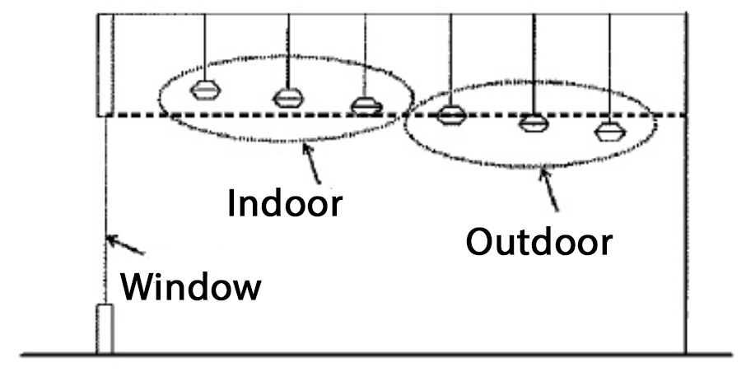
Elevation view showing an example of a nonresidential application of indoor lighting, labeled “Outdoor”, which is will be subject to this article. The example presumes the structure in question is not elevated such that any of the luminaires labeled “Indoor” may be seen from any other property. If the structure is elevated such that the luminaires labeled “Indoor” are visible from another property then, they are actually “outdoor lighting” and subject to this article. All luminaries under skylights or other translucent roofing materials are subject to this article just as the fixtures behind the window are in this example.

Exhibit 2. An illustration of best outdoor lighting practices.

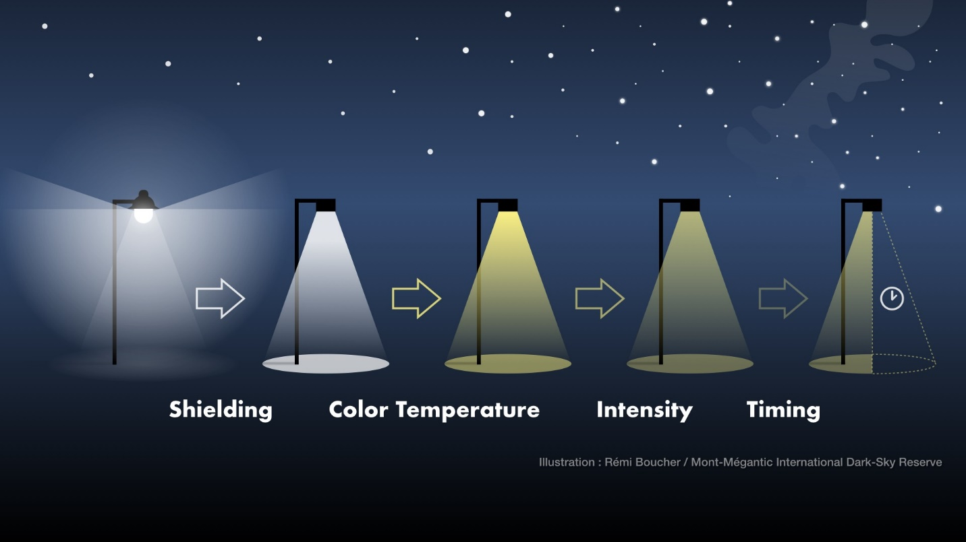

(1) Use shielding to reclaim wasted light and direct it to the area to be lit.

(2) Lower the correlated color temperature (CCT) from “cool” white light to “warm” white.

(3) Lower the intensity to provide as much light as needed for the application, but no more.

(4) Use adaptive controls, e.g., timers, half-night photocells, motion sensors, etc., to limit the hours the light is in use.

Exhibit 3. Light Trespass

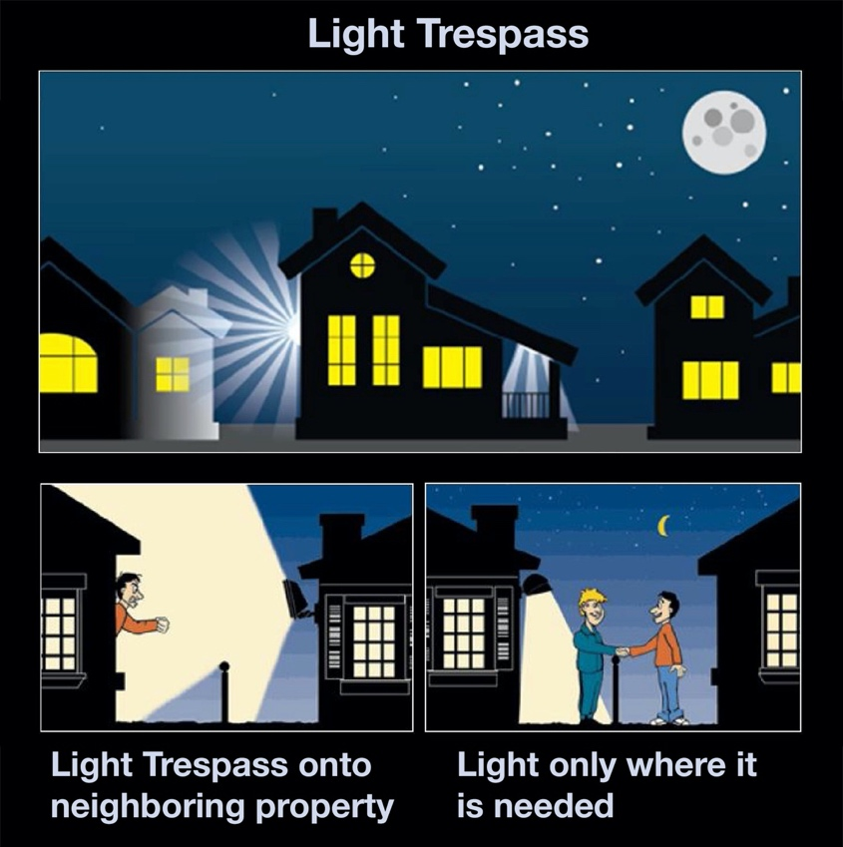

Exhibit 4. Unacceptable Fixtures and Acceptable Fixtures.
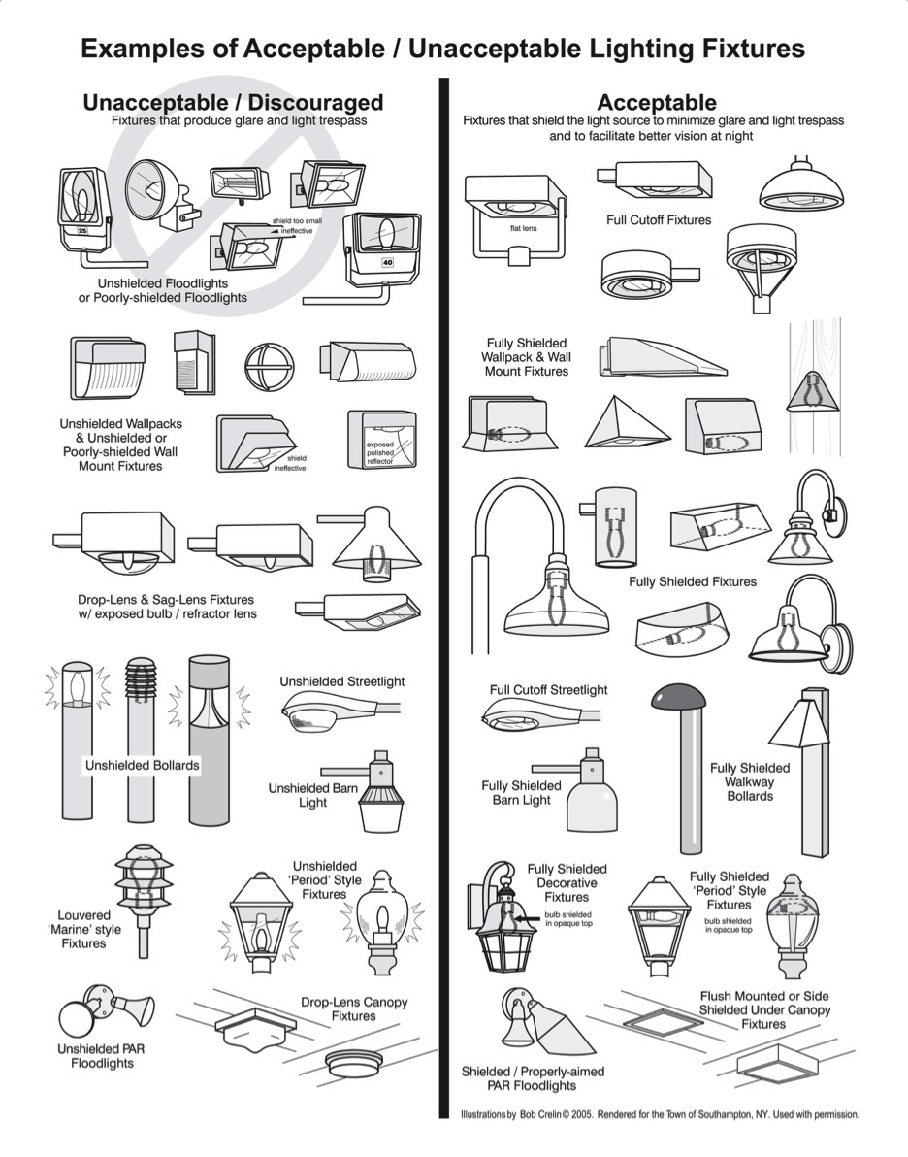

Exhibit 5. Internally Illuminated Signs.

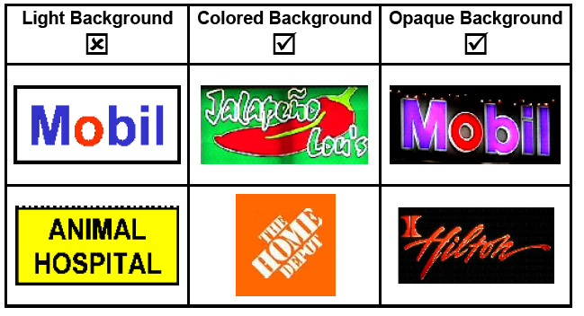

Exhibit 6. Pavement Illuminance Criteria for Full Intersection Lighting in Footcandles (fc).

Type of Roadway | Pedestrian Activity Level |  |  | Uniformity Ratio
 | High | Medium | Low
Major / Major | 3.2 | 2.4 | 1.7 | 3.0
Major / Collector | 2.7 | 2.0 | 1.4 | 3.0
Major / Local | 2.4 | 1.9 | 1.2 | 3.0
Collector/Collector | 2.2 | 1.7 | 1.1 | 4.0
Collector/Local | 2.0 | 1.5 | 0.9 | 4.0
Local/Local | 1.7 | 1.3 | 0.7 | 6.0

