Be A Star Award Application

Part 1
Determine if each light is necessary. Ask yourself what function each light fulfills. Every light should have a clear purpose. Is the light needed? How does it impact the area, including your neighbors, wildlife and the environment? Consider using reflective paints or self-luminous markers for signs, curbs, and steps to reduce the need for permanently installed outdoor lighting. Take the light out of service if it no longer serves a purpose.
Q1A. Do each of your remaining lights serve a purpose? *
- Yes
- No
If ‘No’, disable any lights that do not serve a purpose before proceeding. Resubmit answer Q1A.

Part 2: Shield and Direct Lights Only Where Illumination is Needed
The Better Lights for Better Nights diagram below is a great starting point to learn about fixtures that can shield and control light direction versus fixtures that allow light to go upwards or on adjoining properties. Acceptable light fixtures shield the light source/bulb/LED from normal viewing points and do not allow any light above a horizontal line drawn through the lowest point of the illuminating elements of the fixture. The best fixtures tuck the bulb up in the fixture, minimizing glare and light trespass.

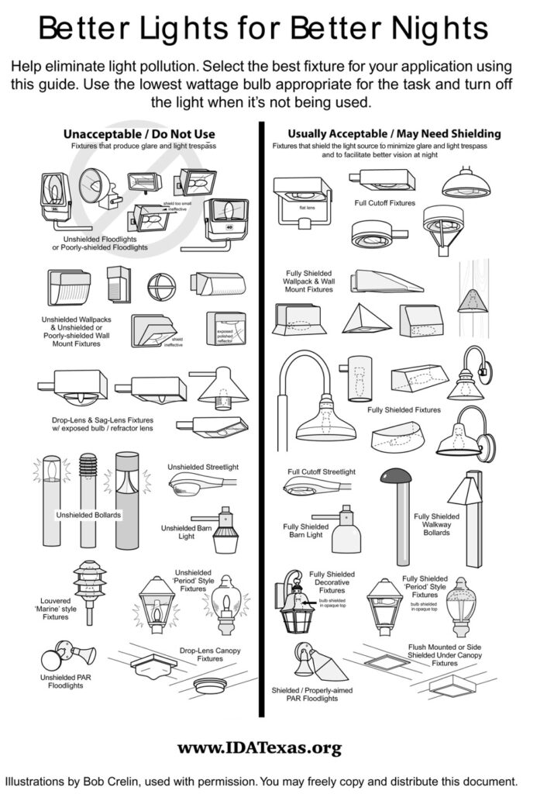

To avoid glare, the eye must be protected from directly viewing an overly bright light source. Even fixtures that are labeled night sky friendly or full cutoff or fully shielded may need additional shielding to actually hide the source of the light from a normal viewing point. Shielding the light concentrates it where it is needed and usually allows you to reduce the wattage to get the same or more usable light. In fact, a wattage reduction is usually required to keep that concentrated light from producing reflective glare and causing an over-lighted situation. Aiming lights “down” does not mean to just angle the light towards the ground. The fixture must be positioned so it does not allow any light to go above a horizontal line drawn through its lowest part. In most applications, this requires the light be installed above the area to be illuminated.
The illumination from a properly installed light fixture should project below and out to the sides of the fixture, like a cone with the peaked top of the light at the fixture. An acceptable fixture that is mounted at an upward angle would normally change it into an “unacceptable” fixture. There are situations where an ‘acceptable fixture’ would require additional shielding: for example, one mounted up on a hill may require the addition of a shroud or shield to keep it from shining directly on other properties.
Low output landscape lighting directed upward and shielded so that no one sees the source of the light from any other property is acceptable if the lights are turned off when no one is actively using them. Remember, both plants and animals need natural darkness to be healthy.
Using a smaller wattage bulb that is low enough to not create glare for light sensitive individuals can improve visibility on your property. Shielding the bulb from view may be done with a durable shield (sheet metal works well), heat resistant paint, or by replacing the fixture with one that hides the light source.
Take a tour and view your property from neighboring areas. Look at it from a nearby hill if possible. If your lights look star-like, you are paying for light to go on your neighbors’ property. Shield your lights and reduce wattage, and your pocketbook and your neighbors will be happier!
Q2A. Do all of your outdoor light fixtures hide the source of the light and direct the light only where it is needed (and below the horizontal)? *
- Yes
- No

Q2B. Are the lights that caused you to answer question Q2A "No" low-output lights directed so no one off your property sees the source of the light, and which are turned off when no one is there to use them?
- Yes
- No

If ‘No’, then your lights may need some adjustments. Please see the examples and suggestions for acceptable light fixtures and installation in Part 2. Resubmit questions Q2A and Q2B.

Part 3: Turn Lights Off When You Are Not There or Use a Motion Sensor or Timer
Professional studies have shown lighting an unoccupied area can attract criminals. It is also a waste of energy. Turning off lights forces criminals to bring their own flashlights, causing them to be more noticeable if anyone is there to see them. It also allows wildlife to exist in the natural light of the stars and moon. Timers, motion detectors, and half-night photocells can provide illumination, if needed, for an area or facility.
Q3. Do you normally turn off outdoor lights at night when no one is using them? *
- Yes
- No

If ‘No’, consider the installation of a timer or motion sensor, or include an explanation in Part 6 of why it is necessary to keep outdoor lights on in your particular situation. Resubmit Q3A.

Part 4: Reduce the Amount of Light - Lumens Matter
The human eye adjusts to the brightest light visible, and thus is ‘blinded’ to dimmer objects or areas. As a result, significantly less light than is the modern habit is best to enhance night vision. Remember that a very bright light will make surrounding unlit areas seem impossibly dark, and mask whatever is in them.
What you cannot tell from the “Better Lights for Better Nights” handout at the beginning of this application is the amount of light that each fixture produces. The amount of light produced is measured in lumens. Too many lumens (i.e. too bright a light) for a particular application will cause light to bounce off of the surfaces it shines on and reflect up in the sky, in the eyes of people trying to see nearby, into the habitat of nearby wildlife, etc. The light may draw in birds and insects that then will not be able to escape and proceed with their natural activities. Reduce the lumens (the amount of light) to let your eyes work as they should.
Did that just say lower the lumens? You bet. When you reduce the amount of light you not only cut the glare and allow people to see better, but by putting light only where it is needed you can get the same amount of usable light with about half the electricity cost of an unshielded light. That's a win-win!
Q4. Do your outdoor lights gently illuminate without glare, allowing you to see beyond the lit area? (If they light up some areas like daylight or create glare for sensitive people, then your answer is no.) *
- Yes
- No

If ‘No’, reduce the amount of light on your property to a level where you can see what you want to see without causing glare and over-lighting. Illuminating an area with shielded lighting at a level appropriate to night-time is your goal when you need artificial light. Note the photo on this page of a 24-hour emergency room. The lights are shielded and don’t look like stars. The parking area and sidewalks are very well lit. After you reduce the wattage on your outdoor lights or reduce the number of fixtures answer Q4 again to determine if your property might qualify for the award.

If yes, you have earned the BE A STAR Award and may move to Part 6 to complete the application!
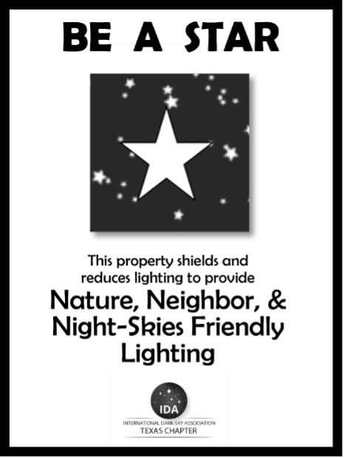

Part 6: Submit Your Application
Name *
First
Last
Layout
Phone
Email *
Address of Property to be Recognized *
Address Line 1
Address Line 2
City, State Zip Code County
Layout
Property Size *
(estimated sq. ft. or acres)
Number of Outdoor Light Fixtures
Answer to each question in the BE A STAR Award application was:
- Yes
- No
Select One
- $10 Application Fee Enclosed. Non-refundable fee to ONLY get the static cling window sticker.
- $42 Application Fee Enclosed. Non-refundable fee to get the unmounted 9” X 12” laminated metal yard sign & static cling window sticker.
- $50 Application Fee Enclosed. Non-refundable fee to get an unmounted 12” X 18” laminated metal yard sign & static cling window sticker.

